Teddy Bear 5K & 1K Fun Walk
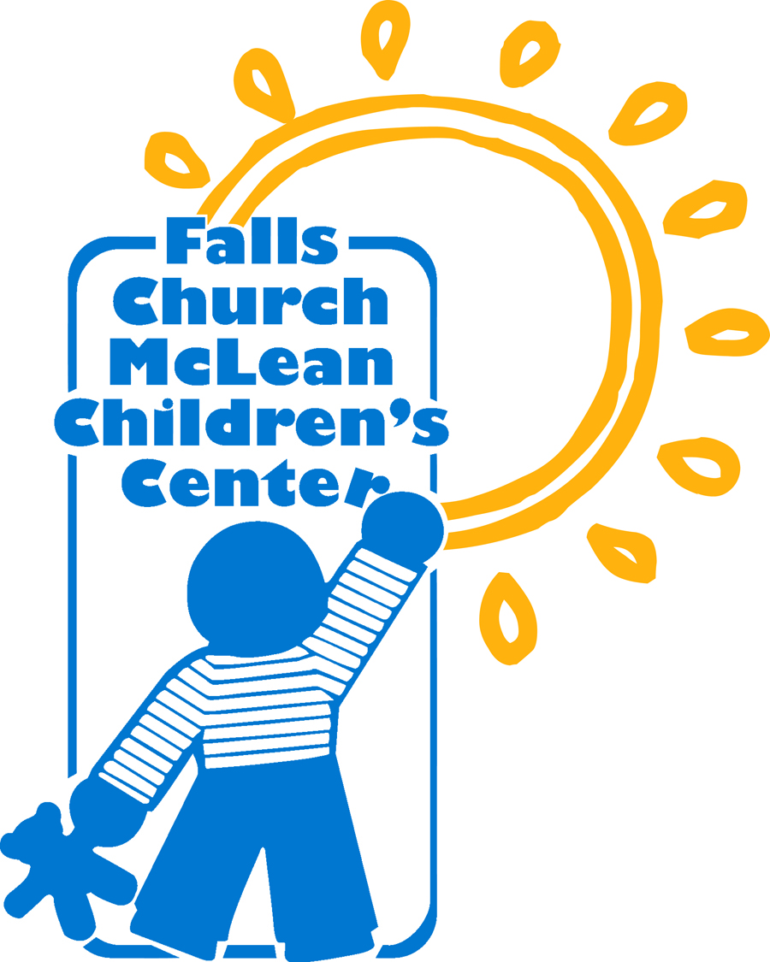
Sunday, Sept. 29, 2013
4 pm
W&OD Trail in Falls Church

We invite your company to sponsor or provide In-Kind Services or Gift Certificates for this healthy, family-friendly public event. Proceeds support the Falls Church-McLean Children’s Center, to keep its high quality, early childhood education program accessible to children from low-income, working families.

Sponsorship levels and benefits are described below. Please complete the registration form and return to the Children’s Center. For details, call Renee Boyle, 703/534-4907 or renee_boyle@fcmlcc.org
• • • • • • • • • • • • • • • • • • • • • • • • • • • • • • • • • • • • • • • • • • • • • • • • • • • • • • • • • • • • • • • • • • • • • • • • • • • • • • • • • • • •

Sponsor Opportunities
Presenting Sponsor $2,500  - Your Corporate Logo on FCMLCC Bus for 1 year.  - Your Corporate Logo on front of Teddy Bear 5K T-shirts  - Listing on event website and in all event press releases  - Corporate Rep may announce Winners & Award Prizes  - Insert in 150 runners’ goodie bags; display on race day  - Free entry for up to 25 runners  Gold Sponsor $1,000  - Your corporate logo on front of Teddy Bear 5K T-shirts  - Listing on event website and in all event press releases  - Insert in 150 runners’ goodie bags; display on race day  - Free entry for up to 10 runners. | Silver Sponsor $500  - Your corporate logo on back of Teddy Bear 5K T-shirts  - Listing on event website and in all event press releases  - Insert in 150 runners’ goodie bags; display on race day  - Free entry for up to 5 runners on your team.  Bronze Supporter $250  - Your corporate name on back of Teddy Bear 5K T-shirts  - Listing on event website and in all event press releases  - Insert in 150 runners’ goodie bags; display on race day  - Free entry for up to 3 runners  In-Kind Supporter  - Listing on event website; display on race day

Please send this completed form with your check (payable to FCMLCC) or credit card information to
Falls Church-McLean Children’s Center, Falls Church, VA 22043
Please write legibly:
Organization ___________________________________will Sponsor at the Level: _______________________
Contact Name ________________________________________ Business Phone __________________
Address ________________________________________________________________________________
City, State, ZIP ________________________________________________________________________________
E-mail ______________________________________________ Web Page ______________________________
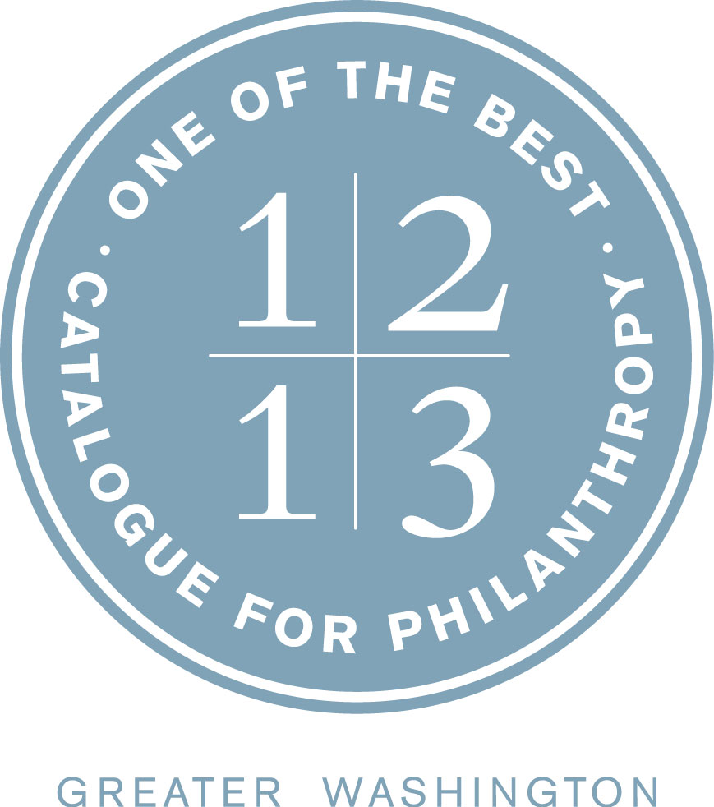
[_] Enclosed is a check for $ ________________ [_] Please charge my card for $_______
[_] Discover [_] Master [_] VISA __ __ __ __ - __ __ __ __ - __ __ __ __ - __ __ __ __
Exp.Date __ __ - __ __
Name on card ______________________________________ Card Code ___ ___ ___
[_] I pledge in-kind support _________________________________
(e.g., printing t-shirts, refreshments)
[_] Enclosed are Gift certificates from my store or business

In its 45th year, the Falls Church-McLean Children’s Center is dedicated to helping
all children, regardless of their family’s resources, to build the skills they need for a
strong foundation on which to build the rest of their lives.
7230 Idylwood Road Falls Church, VA 22043 703/534-4907 www.fcmlcc.org

