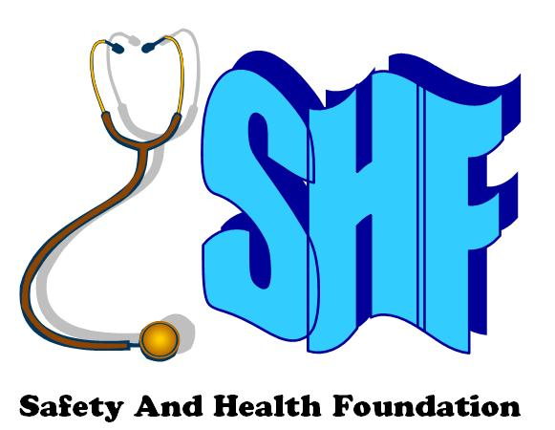
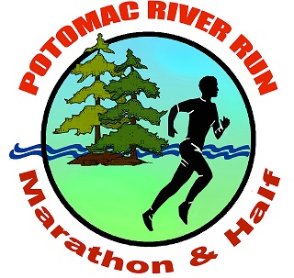

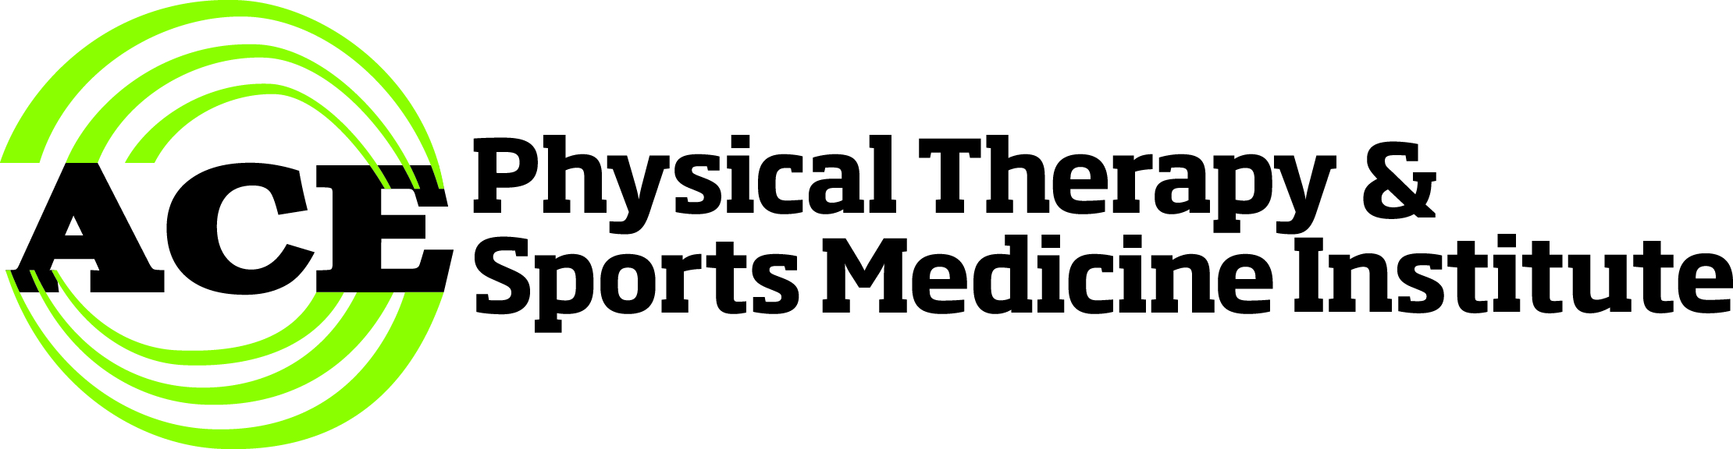
^{21st annual}

POTOMAC RIVER RUN MARATHON & HALF
Satuday, May 4, 2024
8 AM Marathon – 9 AM Half Marathon
The easiest marathon in America - Celebrating World Laughter Day
On the historic C&O Canal Towpath -- Start & finish at Fletcher’s Cove, Washington DC
Enter early at www.safetyandhealthfoundation.org/marathon and save!

• Sponsored by • Carb Boom (Boom Nutrition), Pacers Running Stores, Trader Joes, and more
• Course • Flat - scenic – tree-lined - shaded – beautiful views of Potomac River – • Enjoy a lovely day on the C&O Canal Towpath!
• Boston Qualifier marathon USATF-certified course DC-09005-RT • Post-race picnic
• Colorful, technical grade t-shirt • Goodie bag with samples, coupons & gift certificates
• Pre-Race • Packet assembly+pick-up Thursday, May 2, 5-7 PM, ACE Physical Therapy, 2841 Hartland Road #401, Falls Church VA
• Packet pick-up Friday, May 3, 12:00 noon-5:45 PM, Pacers Running Store, 3100 Clarendon Boulevard, Arlington VA

• Pre-race dinner at Big Tony’s Pizzeria, next door to Pacers, Friday, May 3, 6:15 PM, 3100 Clarendon Blvd, Arlington
• Race-Day • Packet pick-up Saturday, May 4, 7:15–8:45 AM, at Fletcher’s Cove, 4940 Canal Road, Washington DC
• 7:30 AM & 8:30 AM – Laughing Warm-Up, led by Diane Cohen, Arlington Laughter Yoga
• 7:50 AM & 8:50 AM – National Anthem, played by 20-time finisher Michael Creadon, followed by official welcome
• 8:00 AM – FULL Marathon • Qualifier for Chicago, Houston, Los Angeles, NYC, Olympic Trials Marathon & Boston
• 9:00 AM – HALF Marathon • Qualifier for Chicago, Houston, Los Angeles, NYC, Olympic Trials Marathon
• Aid stations at Lock 10, Lock 7, Lock 5, by Buy A Brick Foundation www.TeamAfrica.com, DC Capital Striders, and Marathon Charity Cooperation
• Refreshments courtesy of sponsors Boom Nutrition, Big Tony’s Pizzeria, Pacers Running Stores, and Trader Joe’s. Medals by Dan Kain Trophies.
• Awards • Marathon: $250 to 1st, $150 to 2nd, $100 to 3rd M/F – Commemorative awards to 1st, 2nd, 3rd 10-year age-group M/F
• Half Marathon: Commemorative awards to 1st, 2nd, 3rd M/F overall and 1st, 2nd, 3rd 10-year age-group M/F
• Benefits • Safety And Health Foundation, Buy A Brick Foundation, DC Capital Striders, Marathon Charity Cooperation
• Open to all • 300 marathoners of all abilities who can cover the marathon course in less than 6 hours or half marathon less than 5 hours (walk OK)
• Lodging • $210 at Crystal City Marriott Reagan National Airport, 1999 Richmond Highway, Arlington VA (703-413-5500) "SHF Marathon 2022”
• Directions • From Georgetown, go west on M Street to Foxhall Road. Stay left onto Canal Road.
About two miles west, watch for Reservoir Road on your right and a break in the stone wall on your left.
CAREFULLY turn left down the driveway to free parking on the left, or go thru the tunnel on the right
to more free parking by the river. You can also park on Reservoir Road or any of the connecting streets
• You can also take Red Top Cab for $10 round trip, leaving at 7:00 AM from Crystal City Marriott, returning whenever 4 are finished
• You may drop off your runners and then watch as a spectator at Chain Bridge, Lock 5, Lock 6, Lock 7, Lock 8, Lock 9, or Lock 10

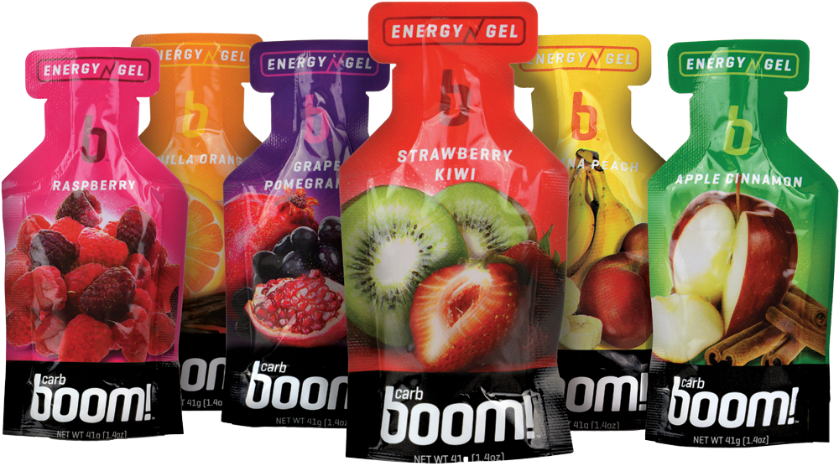

• Sponsor us! • www.safetyandhealthfoundation.org/marathon or call 703-927-4833 / racedirector@att.net Sponsors:

ACE PHYSICAL THERAPY & SPORTS MEDICINE INSTITUTE
POTOMAC RIVER RUN MARATHON • REGISTRATION FORM
Make checks payable to SHF • 611 South Ivy Street • Arlington VA 22204
By entering this event, I agree, warrant and covenant as follows: I know that running is a potentially hazardous activity. I should not enter or run in competitive runs unless I am medically able and properly trained. I agree to abide by any decision of a race official relative to my ability to safely complete the run. I assume all risks associated with running in this race including, but not limited to, CONTRACTION OF ILLNESS INCLUDING COVID-19, falls, contact with other participants, the effects of weather, including high heat and/or humidity, the conditions of the road and traffic on the course, all such risks being known and appreciated by me. Having read this waiver and knowing these facts, and in consideration of your acceptance of my application, I, for myself and anyone entitled to act on my behalf, waive and release By A Brick Foundation, DC Capital Striders Running Group, Safety And Health Foundation, Marathon Charity Cooperation, RRCA, USATF, National Park Service, and all sponsors of this event, their directors, officers, employees, agents, representatives, and successors from all claims or liabilities of any kind arising out of my participation in this event even though that liability may arise out of negligence or carelessness on the part of the persons named in this waiver. I acknowledge that the application fee shall be non-refundable. I agree that the organizers of this event may use my name and likeness for publicity purposes.

Signature ______________________________________ (parent or guardian if under 18)

Name ___________________________________________________________________________________ Gender [___] (M | F) Age on 5/1/2022 [__ __]

Address ___________________________________________________________________________________ Birthday ___ ___-___ ___-___ ___ ___ ___ (mm-dd-yyyy)

City ST ZIP ________________________________________________________________________________________________________________________________

E-mail ____________________________________________________________________________________________________________________________________

Phone ___ ___ ___-___ ___ ___-___ ___ ___ ____ T-shirt size [___] XS | S | M | L | XL | XXL [__] Add $5 one-way or $10 round-trip Red Top Cab ride

Best Marathon __:__ __:__ __ Where/When?______________________________________________ [__] Add $10 for dinner Bronx Pizza, Saturday, Apr 30, 6:30 PM

Event: [__] 9:00 AM Half marathon [__] 8:00 AM Full Marathon Save $50 by registering early at www.safetyandhealthfoundation.org/marathon

Enclosed: $70 after November 1, $80 after January 1, $90 after March 1, $100 after April 1, $250 after April 27 or at packet pick-up -- $10 military and club discount
[__] Enclosed is an additional tax-deductible donation (enclose separate check) [__] BuyaBrick [__] DC Capital Striders [__] MCC [__] Safety And Health Foundation

