9th Annual Potomac River Run Marathon & Half
Carderock Recreation Area MD 2013
Sunday, May 6, 2012 6:30 AM Full Marathon Marathon Boston
Bib ## Name G Age City State Time Event Start Award Qualifer?
--- -- -------------------------- - --- ---------------- ------ ----- ----- -------- ---
679 1 David Coligado M 34 Chicago IL 3:14:38 Full 6:30
540 2 Steve Troyano M 36 Arlington VA 3:20:44 Full 6:30
683 3 Patrick Morley Conway M 39 Washington DC 3:20:49 Full 6:30
118 4 Jennifer Ann Bailey F 34 Southern Pines NC 3:24:48 Full 6:30 BQ!
532 5 Oskar Tiger M 39 Washington DC 3:29:55 Full 6:30
233 6 Juan Elizondo M 50 South Padre Island TX 3:32:38 Full 6:30
472 7 Erik Runko M 38 Bethesda MD 3:33:55 Full 6:30
499 8 Amy M. Shopkorn F 34 Falls Church VA 3:36:54 Full 6:30 BQ!
285 9 Benjamin Hess M 31 Arlington VA 3:38:54 Full 6:30
488 10 Rachel Scott F 28 Falls Church VA 3:39:02 Full 6:30
596 11 William Kenneweg M 56 Port Townsend WA 3:39:28 Full 6:30 BQ!
326 12 Heather Kizer F 36 Southern Pines NC 3:39:55 Full 6:30 BQ!
425 13 Jason Park M 36 Washington DC 3:46:49 Full 6:30
495 14 Mike Sheahan M 36 Washington DC 3:47:42 Full 6:30
546 15 Vishal Verma M 40 Glen Allen VA 3:47:56 Full 6:30
306 16 Wim Imron M 56 Forest VA 3:48:27 Full 6:30
117 17 Manhang Bae M 61 Laurel MD 3:48:57 Full 6:30 BQ!
471 18 Alexander P. Runko M 38 Kensington MD 3:49:35 Full 6:30
220 19 Jim Diffell M 54 Columbia MD 3:50:07 Full 6:30
318 20 Edward Keusenkothen M 45 Reston VA 3:51:44 Full 6:30
258 21 Patrick Garrett M 46 Derry NH 3:52:34 Full 6:30
603 22 Etta Mayer F 61 Lubbock TX 3:55:01 Full 6:30 BQ!
575 23 Akiko Yoshihara F 29 Washington DC 3:57:16 Full 6:30
497 24 Niki Shimasaki M 40 Washington DC 3:57:18 Full 6:30
393 25 Steve Michener M 38 Arlington VA 3:57:41 Full 6:30
224 26 James Dishaw M 42 Burke VA 3:58:08 Full 6:30
493 27 Ginni Shitij Sharma M 39 Ashburn VA 3:58:45 Full 6:30
445 28 Charmaine Reed F 42 Springfield VA 3:59:02 Full 6:30
230 29 Mike Durband M 37 Fairfax Station VA 4:02:46 Full 6:30
396 30 Eve Mills F 46 Bethesda MD 4:05:32 Full 6:30
601 31 Jason Robert Schwartz M 41 Potomac MD 4:07:39 Full 6:30
437 32 Karen Preston F 34 Ashburn VA 4:09:10 Full 6:30
513 33 Laura Stevenson F 35 Midlothian VA 4:11:42 Full 6:30
553 34 Anthony Wang M 42 Gaithersburg MD 4:12:16 Full 6:30
585 35 Gillian Rowan F 57 Arlington VA 4:12:21 Full 6:30
332 36 Julie L. Kogut F 46 Germantown MD 4:12:31 Full 6:30
474 37 Ernest Scott Ryan M 61 Clarksburg MD 4:13:56 Full 6:30
458 38 Pamela Ritzler F 30 Bethesda MD 4:15:25 Full 6:30
384 39 Borna Mehrad M 44 Charlottesville VA 4:15:29 Full 6:30
390 40 Allyson Ruth Metell Cook F 36 Oak Bluffs MA 4:15:58 Full 6:30
229 41 Summer Dawn DuPont F 36 Fayetteville NC 4:16:52 Full 6:30
269 42 Heather Grim F 35 Manassas VA 4:17:04 Full 6:30
453 43 Jessica Rich F 29 Arlington VA 4:17:17 Full 6:30
556 44 Kristin Albright Waters F 29 Annapolis MD 4:18:17 Full 6:30
51 45 Mordechai Abrahams M 37 Pikesville MD 4:19:02 Full 6:30
232 46 Darla J. Edmonds F 49 Vienna VA 4:20:46 Full 6:30
122 47 Melisa Banks F 43 Falls Church VA 4:24:07 Full 6:30
448 48 Nicole I. Reinking F 32 Lancaster PA 4:24:25 Full 6:30
547 49 Ernie Villacarlos M 48 Damascus MD 4:24:30 Full 6:30
517 50 Chris M. Streeter M 51 Mitchellville MD 4:25:20 Full 6:30
443 51 Shanan Redinger F 37 Hanlontown IA 4:26:44 Full 6:30
442 52 Aaron Redinger M 38 Hanlontown IA 4:26:45 Full 6:30
469 53 Larry Rubenstein M 63 Oklahoma City OK 4:28:20 Full 6:30
694 54 Hannah Lee Creek F 19 Hancock MD 4:31:01 Full 6:30
131 55 Lisa Christine Belcastro F 48 Vineyard Haven MA 4:31:41 Full 6:30
419 56 Robin Osterhout F 39 Centreville VA 4:32:21 Full 6:30
268 57 Lindsey Grilliot F 36 Reston VA 4:35:10 Full 6:30
571 58 Kelly Anne Wrightson F 24 Germantown MD 4:36:07 Full 6:30
572 59 Lindsay Wrightson F 29 Decatur GA 4:36:08 Full 6:30
138 60 Timothy Andrew Bradford M 40 Annapolis MD 4:38:44 Full 6:30
367 61 Robert Mahon M 41 Seattle WA 4:38:51 Full 6:30
340 62 Donald Landry M 66 Montreal QC 4:39:57 Full 6:30
298 63 Seth Michael Howard M 17 Libertytown MD 4:40:01 Full 6:30 (started 15 min.late)
378 64 Jack McDermott M 43 Tallahassee FL 4:40:30 Full 6:30
379 65 Laura McDermott F 32 Tallahassee FL 4:40:32 Full 6:30
558 66 Adam Weiss M 48 Linwood NJ 4:43:44 Full 6:30
543 67 Stephanie Vail F 29 Fairfax VA 4:44:28 Full 6:30
239 68 Victoria Fachino F 30 Chesapeake VA 4:46:39 Full 6:30
149 69 Marlon Brown M 33 Laurel MD 4:47:17 Full 6:30
538 70 Nicole M. Trenholm F 26 Solomons MD 4:47:37 Full 6:30
550 71 Carol Wade F 49 Chesapeake VA 4:47:46 Full 6:30
539 72 Shannon Trimmer F 30 Columbus OH 4:48:42 Full 6:30
147 73 Gretchen Nicole Brown F 40 Fairfax VA 4:49:23 Full 6:30
479 74 Hiroyuki Sasai M 29 Rockville MD 4:49:32 Full 6:30
116 75 Melissa Aune F 31 Chantilly VA 4:50:14 Full 6:30
140 76 Richard Britton M 57 St. Leonard MD 4:53:30 Full 6:30
344 77 Kihoon Lee M 51 Gaithersburg MD 4:53:32 Full 6:30
669 78 Thomas Chang M 45 Potomac MD 4:53:34 Full 6:30
101 79 Jo Agnew F 41 Philadelphia PA 4:55:52 Full 6:30
102 80 Kelly Agnew M 39 Philadelphia PA 4:55:53 Full 6:30
343 81 Franklin Lartey M 27 Laurel MD 4:57:19 Full 6:30
145 82 Linsi Broom F 28 Arlington VA 4:59:00 Full 6:30
529 83 Emily Brooke Thompson F 28 Arlington VA 4:59:10 Full 6:30
680 84 Denise Collins F 34 Leesburg VA 5:01:15 Full 6:30
123 85 Yahly Bar Lev F 27 Washington DC 5:02:17 Full 6:30
137 86 Alison Anne Bouquet F 48 Bethesda MD 5:03:46 Full 6:30
399 87 Heather Montague F 37 Annapolis MD 5:04:50 Full 6:30
655 88 James W. Busch M 42 Suffolk VA 5:05:46 Full 6:30
247 89 Marina Franklin F 32 Chantilly VA 5:06:02 Full 6:30
376 90 Sean McCahill M 39 Alexandria VA 5:07:42 Full 6:30
124 91 Rahul Bardhan M 47 Fairfax VA 5:09:15 Full 6:30
524 92 Jill Tecler F 37 Washington DC 5:11:18 Full 6:30
253 93 Shawn Gaines M 40 Centreville VA 5:13:04 Full 6:30
478 94 Patricia D. Santos-Ciminera F 41 West River MD 5:13:23 Full 6:30
382 95 Lisa B. McKnight F 51 Richmond VA 5:13:42 Full 6:30
206 96 Merav Davidovits F 41 Washington DC 5:15:21 Full 6:30
400 97 Lori Morgan F 39 Wilmington DE 5:16:23 Full 6:30
110 98 Carolyn Andrews F 27 Nashua NH 5:16:25 Full 6:30
278 99 Julia Hartsock F 31 Martinsburg WV 5:18:50 Full 6:30
279 100 Thomas Hartsock M 42 Martinsburg WV 5:18:51 Full 6:30
372 101 Edward J. Masuoka M 59 Laurel MD 5:21:27 Full 6:30
304 102 James Hyche M 63 Baltimore MD 5:24:03 Full 6:30
245 103 Michael Corey Foster M 40 Chesapeake Beach MD 5:24:19 Full 6:30
455 104 Christina Richey F 29 Odenton MD 5:25:03 Full 6:30
309 105 Lien James F 60 Washington DC 5:27:47 Full 6:30
674 106 Beth Cleveland F 46 Centreville VA 5:28:37 Full 6:30
675 107 John Cleveland M 46 Centreville VA 5:28:38 Full 6:30
527 108 Kevin Thomas M 41 Accokeek MD 5:30:17 Full 6:30
700 109 Kelly Jean Curtis F 43 Oakton VA 5:31:55 Full 6:30
349 110 Monika Lev-Cohen F 40 Rockville MD 5:39:23 Full 6:30
586 111 David Sands M 35 Washington DC 5:39:51 Full 6:30
109 112 Zeke Anthony Andre M 46 Yorktown VA 5:48:53 Full 6:30
577 113 Jesse Zabal F 25 Alcoa TN 5:50:44 Full 6:30
341 114 Marion Landry F 67 Montreal QC 5:51:20 Full 6:30
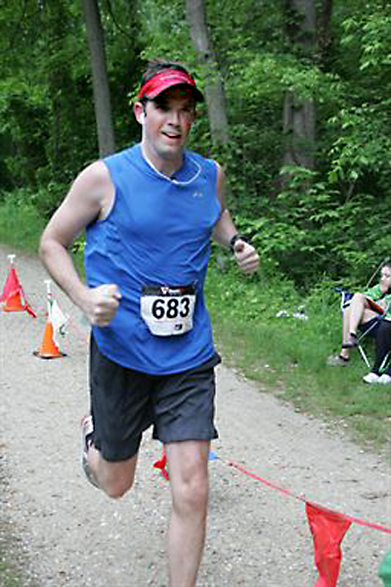
446 115 Johana A. Reed F 52 Ashburn VA 5:51:33 Full 6:30
352 116 Roxana N. Lewis F 66 Gardena CA 5:52:52 Full 6:30
450 117 Mario Inti Reyes M 31 Gainesville VA 5:58:29 Full 6:30
686 118 Patricia Ann Cote-Miles F 60 Tyrone GA 6:00:03 Full 6:30
507 119 Stephen Smyers M 30 Arlington VA 6:03:58 Full 6:30
434 120 Ruth Porter F 28 Arlington VA 6:04:00 Full 6:30
135 121 Bernadette M. Bisbing F 31 Philadelphia PA 6:05:43 Full 6:30
290 122 Beata Ho F 27 Atlanta GA 6:05:55 Full 6:30
246 123 Cherie Frank F 42 Savannah GA 6:05:57 Full 6:30
287 124 Don Higdon M 70 Severna Park MD 6:06:56 Full 6:30
406 125 William Myers M 62 Gambrills MD 6:06:59 Full 6:30
526 126 Emmy Tello F 48 Alexandria VA 6:09:49 Full 6:30
266 127 Peter Stephen Graham M 46 London GBR 6:12:56 Full 6:30
283 128 Julia Heflin F 33 Herndon VA 6:15:40 Full 6:30
334 129 Aparna Kolhekar F 48 Potomac MD 6:21:59 Full 6:30
663 130 Robyn L. Carbonara F 36 Elizabeth NJ 6:22:02 Full 6:30
297 131 Heidi Howard F 24 Libertytown MD 6:33:19 Full 6:30
296 132 Emily Charissa Howard F 20 Libertytown MD 6:33:28 Full 6:30 Patrick Conway
522 133 Donald John Taylor M 81 Hedgesville WV 6:46:04 Full 6:30
410 134 Leah Nicholas F 37 Sayreville NJ 6:55:00 Full 6:30

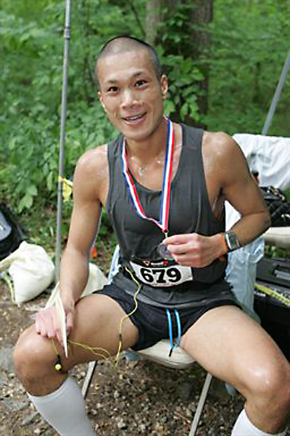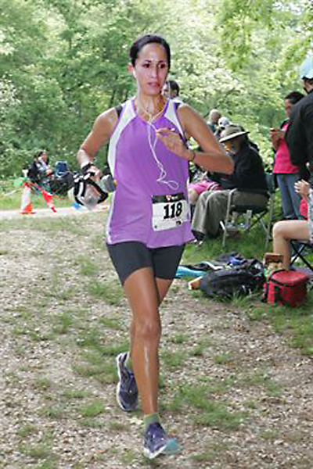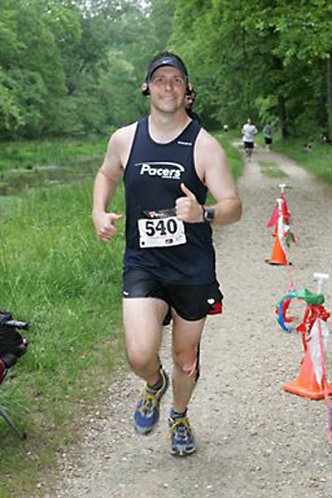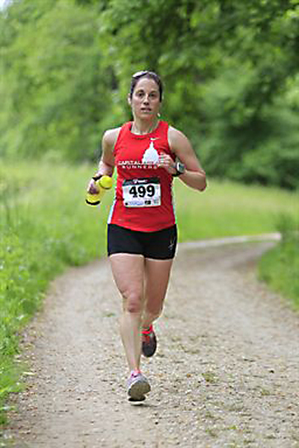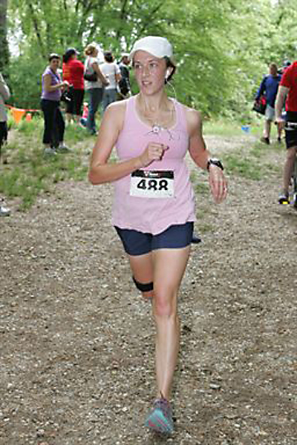
David Coligado Jennifer Ann Bailey Steve Troyano Amy Shopkorn Rachel Scott
Carderock Recreation Area MD 2013
Sunday, May 6, 2012 6:30 AM Full Marathon Marathon Boston
Bib ## Name G Age City State Time Event Start Award Qualifer?
--- -- -------------------------- - --- ---------------- ------ ----- ----- -------- ---
319 1 Kaleb Keyserling M 25 Chapel Hill NC 2:48:24 Full 7:30 M 1 BQ!
310 2 Thomas Francis Jensen M 48 Oakton VA 2:55:43 Full 7:30 M 2 BQ!
211 3 Greg Dawson M 46 Williamsburg VA 3:00:49 Full 7:30 M 3 BQ!
423 4 Chris R. Palos M 44 Ashburn VA 3:00:54 Full 7:30 M40-49 1 BQ!
407 5 Steven Najjar M 47 Longwood FL 3:04:42 Full 7:30 M40-49 2 BQ!
115 6 Gregory Ashe M 45 Potomac MD 3:05:34 Full 7:30 M40-49 3 BQ!
523 7 Leonard Tchuindjo M 44 Bethesda MD 3:05:42 Full 7:30 BQ!
132 8 Eliav Y. Benjamin M 40 Washington DC 3:08:05 Full 7:30 BQ!
671 9 Judy Y.-C. Chen F 36 Chevy Chase MD 3:08:15 Full 7:30 F 1 BQ!
566 10 Reynolds Wilson M 40 Arlington VA 3:09:28 Full 7:30 BQ!
551 11 Brian Walsh M 28 Washington DC 3:13:48 Full 7:30 M20-29 1
594 12 Jeff Dalhoff M 42 Silver Spring MD 3:14:55 Full 7:30 BQ!
313 13 Isaiah Joo M 22 Washington DC 3:15:31 Full 7:30 M20-29 2
305 14 Moises Iglesias M 37 Fredericksburg VA 3:15:33 Full 7:30 M30-39 1
599 15 Brian Smith M 38 Washington DC 3:16:42 Full 7:30 M30-39 2
477 16 Christopher Goetzman M 31 Arlington VA 3:17:31 Full 7:30 M30-39 3
389 17 Ramage Mendez M 26 Bristow VA 3:17:46 Full 7:30 M20-29 3
439 18 Jennifer Quarles F 40 Williamsburg VA 3:18:24 Full 7:30 F 2 BQ!
690 19 Cullen Cowley M 43 Rockville MD 3:18:41 Full 7:30
134 20 Arie Beresteanu M 42 Pittsburgh PA 3:18:47 Full 7:30
600 21 Julian Mendoza Jr. M 25 Arlington VA 3:20:08 Full 7:30
466 22 Geoff Rosenthal M 52 Millersville MD 3:24:21 Full 7:30 M50-59 1 BQ!
219 23 Mark Dickson M 48 Arlington VA 3:24:22 Full 7:30 BQ!
684 24 Peter John Coppolino M 45 Gainesville VA 3:24:32 Full 7:30 BQ!
301 25 Raymond Anthony Hunce M 26 Yorktown Heights NY 3:26:32 Full 7:30
580 26 Bruce Leland Caswell M 46 Kensington MD 3:27:46 Full 7:30
260 27 John Andrew Gendron M 20 Baltimore MD 3:29:00 Full 7:30
473 28 Kim Ruple F 46 Tyrone GA 3:32:15 Full 7:30 F 3 BQ!
654 29 Mia Burki F 31 Falls Church VA 3:32:49 Full 7:30 F30-39 1 BQ!
409 30 Patrick Newman M 35 Centerville UT 3:33:35 Full 7:30
392 31 Michael Meyer M 50 Fredericksburg VA 3:34:12 Full 7:30 M50-59 2
276 32 Richard Philip Hanno M 49 Bowie MD 3:34:40 Full 7:30
261 33 Gabriel Ghiaur M 34 Baltimore MD 3:36:27 Full 7:30
337 34 Victor John Kunze M 45 Silver Spring MD 3:36:37 Full 7:30
391 35 Lauren Metzger F 23 Chapel Hill NC 3:37:47 Full 7:30 F20-29 1
692 36 Christopher M. Crawford M 35 Ruckersville VA 3:38:02 Full 7:30
544 37 Matthew Vann M 36 Springfield VA 3:39:23 Full 7:30
681 38 Cindy Conant F 51 Kensington MD 3:40:06 Full 7:30 F50-59 1 BQ!
312 39 Erik David Johnson M 29 Vienna VA 3:40:42 Full 7:30
150 40 Scott Brown M 30 Gaithersburg MD 3:41:07 Full 7:30
584 41 Brian Rhee M 47 Great Falls VA 3:41:35 Full 7:30
216 42 Anthony DeLauder M 26 Kensington MD 3:42:01 Full 7:30
652 43 John Bruno M 26 Alexandria VA 3:43:07 Full 7:30
525 44 David Teklits M 32 Philadelphia PA 3:43:57 Full 7:30
412 45 Margaret O'Connor F 26 Washington DC 3:44:11 Full 7:30 F20-29 2
456 46 Matthew Richter M 27 Midway Park NC 3:44:40 Full 7:30
214 47 Marina Dejo F 38 Burke VA 3:46:37 Full 7:30 F30-39 2
588 48 Steve Taylor M 45 Bel Air MD 3:47:30 Full 7:30
486 49 Ryan Earl Schmidt M 21 Landenberg PA 3:47:52 Full 7:30
282 50 Peter R. Hedlund M 26 Columbia MD 3:48:02 Full 7:30
353 51 Adam Lichtenheld M 27 Washington DC 3:48:19 Full 7:30
380 52 Robert Todd McKee M 40 Odenton MD 3:48:32 Full 7:30
119 53 Isabel Dejo Balke F 36 Burke VA 3:49:08 Full 7:30 F30-39 3
255 54 Janet Gallo F 48 Martinez GA 3:50:39 Full 7:30 F40-49 1 BQ!
293 55 John K. Hord M 44 Washington DC 3:50:42 Full 7:30
682 56 Leah Michelle Conte F 33 Centreville VA 3:50:45 Full 7:30
447 57 Yoav Regev M 33 Washington DC 3:51:02 Full 7:30
574 58 Sarah Yates F 25 Charlottesville VA 3:51:39 Full 7:30 F20-29 3
430 59 Amy C. Perkins F 47 Leesburg VA 3:51:53 Full 7:30 F40-49 2 BQ!
288 60 Chris Alan Higginbotham M 43 Alexandria VA 3:52:22 Full 7:30
289 61 Jennifer Boutselis Higginbotham F 31 Alexandria VA 3:52:23 Full 7:30
404 62 Ki Mun M 44 Fairfax VA 3:52:49 Full 7:30
536 63 Lisa Totten F 46 Warrenton VA 3:54:13 Full 7:30 F40-49 3 BQ!
316 64 Andrea Keane-Myers F 43 Bethesda MD 3:54:59 Full 7:30
570 65 Tuesdi Woodworth F 50 Bar Harbor ME 3:55:05 Full 7:30 F50-59 2 BQ!
428 66 Radames Pena M 41 Alexandria VA 3:55:07 Full 7:30
502 67 Gareth Smail M 26 Washington DC 3:56:11 Full 7:30
531 68 Mary Thorson F 32 Ashburn VA 3:56:19 Full 7:30
363 69 Jason G. Lutz M 30 South Charleston WV 3:56:50 Full 7:30
333 70 Erik Kojola M 25 Washington DC 3:56:53 Full 7:30
515 71 Ask Eirik Storsve M 37 Silver Spring MD 3:57:05 Full 7:30
369 72 Marian Manlove F 45 Arlington VA 3:57:27 Full 7:30
272 73 Nils Roland Gyllenhammer M 48 Hillsborough NJ 3:57:36 Full 7:30
697 74 Carina Anne Cuellar F 32 Arlington VA 3:57:48 Full 7:30
104 75 Michael Joseph Alves M 38 Pawtucket RI 3:57:58 Full 7:30
467 76 Lindsay Anne Ross F 22 Chapel Hill NC 3:58:17 Full 7:30
257 77 Karen L. Gardner F 52 Keedysville MD 3:59:29 Full 7:30 F50-59 3 BQ!
112 78 Joshua Arkin M 32 Washington DC 4:02:42 Full 7:30
249 79 John French M 24 Derwood MD 4:02:44 Full 7:30
321 80 Natacha Kiler F 31 Washington DC 4:03:47 Full 7:30
548 81 Lita Vincavage F 30 Richmond VA 4:04:11 Full 7:30
203 82 Samantha D'Alessio F 39 Arlington VA 4:05:06 Full 7:30
204 83 Jeffrey Daniels M 33 Washington DC 4:05:58 Full 7:30
265 84 Kirk Gordon M 56 Glenn Dale MD 4:08:11 Full 7:30 M50-59 3
114 85 Tori Arnold F 24 Frederick MD 4:08:35 Full 7:30
693 86 Michael William Creadon M 44 Arlington VA 4:08:39 Full 7:30
370 87 Connie Martinez F 49 Chaptico MD 4:08:48 Full 7:30
347 88 Robin J. Lerner F 49 Bethesda MD 4:09:49 Full 7:30
328 89 Jane Adair Klinger F 22 Washington Grove MD 4:09:57 Full 7:30
237 90 Chris Euripides M 44 Fairfax Station VA 4:11:53 Full 7:30
252 91 Joe Fuller M 42 Round Hill VA 4:12:15 Full 7:30
545 92 Steve Vaughn M 53 Poolesville MD 4:13:54 Full 7:30
202 93 Kathryn McCrystal Dahir F 44 Nashville TN 4:14:33 Full 7:30
668 94 Greg Chaconas M 66 Washington DC 4:16:33 Full 7:30 M60-69 1
427 95 Kara Gilpin Pellegrino F 22 Greenwich CT 4:16:57 Full 7:30
656 96 Angela Munhoz Da Rocha Buschle F 51 Curitiba BRAZIL 4:16:59 Full 7:30
657 97 Mauricio Buschle M 54 Curitiba BRAZIL 4:17:01 Full 7:30
368 98 Dan Mamber M 37 Arlington VA 4:17:48 Full 7:30
598 99 Emily Ryan (Grossman) F 37 Alexandria VA 4:19:22 Full 7:30
519 100 Brian David Sweitzer M 36 Reisterstown MD 4:21:03 Full 7:30
120 101 Darlene Baltimore F 38 College Park GA 4:22:35 Full 7:30
226 102 Joanna Dozier F 22 Chapel Hill NC 4:22:36 Full 7:30
307 103 Luther Isaac M 58 Bowie MD 4:22:42 Full 7:30
520 104 Lauren M. Talbot F 22 Baltimore MD 4:23:25 Full 7:30
417 105 Patrick Onstad M 44 Great Falls VA 4:24:53 Full 7:30
667 106 Tricia Cecil F 29 Elkridge MD 4:24:55 Full 7:30
121 107 James P. Bankoff M 43 Washington DC 4:25:06 Full 7:30
506 108 David T. Smorodin M 55 Fairfax Station VA 4:26:20 Full 7:30
238 109 Zachary Fabish M 32 Washington DC 4:26:45 Full 7:30
263 110 Kate Gibson F 29 Washington DC 4:27:46 Full 7:30
569 111 Charles Emerson Woodward M 63 Rockingham NC 4:28:31 Full 7:30 M60-69 2
589 112 Margaret Thomas F 40 Springfield VA 4:28:53 Full 7:30
105 113 Derek Ammons M 51 Laurel MD 4:30:12 Full 7:30
552 114 Joshua Walters M 32 Fairbanks AK 4:32:15 Full 7:30
377 115 Margo McCarthy F 29 Salisbury MD 4:32:18 Full 7:30
302 116 Hatim Salih Hussein M 48 Alexandria VA 4:34:27 Full 7:30
496 117 Mary D. Shepherd F 56 Reidsville NC 4:36:21 Full 7:30
235 118 Chris Engler M 30 Gambrills MD 4:38:25 Full 7:30
205 119 Pascal Dartevelle M 50 Alexandria VA 4:39:02 Full 7:30
262 120 Ali Giancarlo F 22 College Park MD 4:41:45 Full 7:30
595 121 Joseph D. Horton M 41 Bethesda MD 4:44:27 Full 7:30
670 122 Arnaub Chatterjee M 29 Arlington VA 4:47:10 Full 7:30
338 123 Sedar Mark Timoth LaBarre M 40 Arlington VA 4:47:23 Full 7:30
362 124 James Lutz M 46 McLean VA 4:48:27 Full 7:30
503 125 Carla Smith F 26 Arlington VA 4:48:29 Full 7:30
433 126 Jennifer Pinciotti F 22 Frederick MD 4:48:32 Full 7:30
394 127 Terri Miles F 32 APO AE 4:48:35 Full 7:30
267 128 Mike Green M 41 Washington DC 4:50:11 Full 7:30
323 129 Steve Kim M 36 Gaithersburg MD 4:51:48 Full 7:30
560 130 Steve Wellner M 53 Washington DC 4:55:41 Full 7:30
504 131 Erin Bronwyn Smith F 31 Ellicott City MD 4:57:21 Full 7:30
295 132 Jill Horvatic F 52 New Kensington PA 4:57:53 Full 7:30
88 133 George R. Banker M 62 Oxon Hill MD 4:58:21 Full 7:30 M60-69 3
592 134 Andrew Bell M 30 Bethesda MD 4:59:18 Full 7:30
658 135 Bruce Byers M 61 Falls Church VA 5:00:27 Full 7:30
144 136 Andrew O'Brian Brooks Sr. M 36 Gainesville VA 5:01:44 Full 7:30
555 137 Amanda Watanakunakorn F 29 Canfield OH 5:03:25 Full 7:30
653 138 April Brys F 47 Towson MD 5:10:05 Full 7:30
201 139 John Dagnello M 48 Towson MD 5:10:12 Full 7:30
403 140 Paul A. Mounier M 42 Annandale VA 5:13:53 Full 7:30
581 141 Aileen Kroll F 56 Silver Spring MD 5:16:34 Full 7:30
505 142 Robert Smoot M 55 Forest Hill MD 5:24:40 Full 7:30
573 143 George D. Yannakakis M 80 Sparks-Glencoe MD 5:29:05 Full 7:30 M80-89 1
498 144 Yoshiko Shishime F 48 North Brunswick NJ 5:42:59 Full 7:30
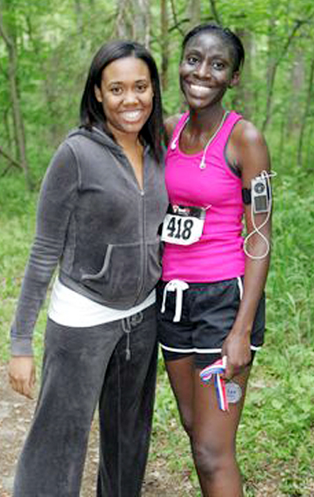
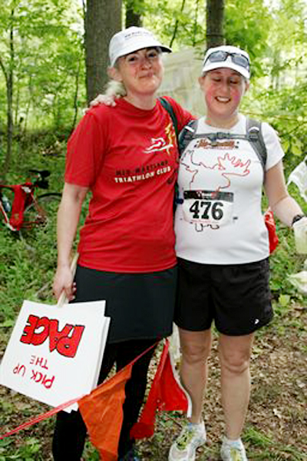
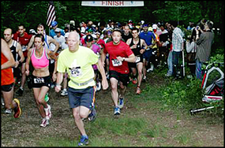
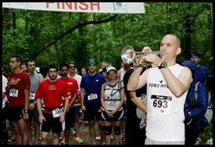
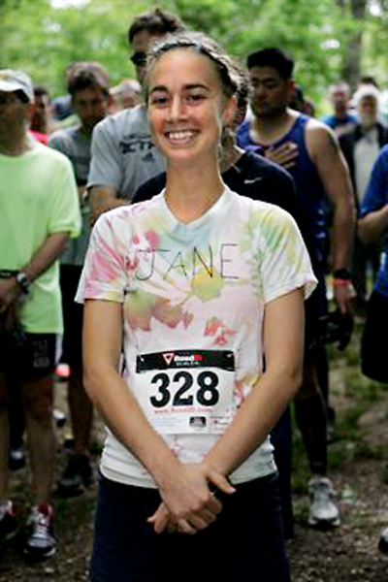
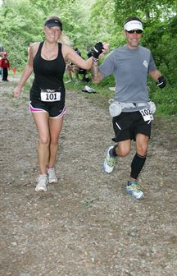
356 145 Salina M. Lindsey F 29 Landover MD 5:48:12 Full 7:30
Carderock Recreation Area MD
Sunday, May 6, 2012 6:30 AM Half Marathon
Bib ## Name G Age City State Time Event Start
--- -- -------------------------- - --- ---------------- ------ ----- -----
489 1 ReBecca Scott F 37 Ashburn VA 1:34:00 Half 6:30
597 2 Noam Neusner M 42 Chevy Chase MD 1:37:51 Half 6:30
248 3 Nadav Freedman M 37 Washington DC 2:01:34 Half 6:30
583 4 Alice Loughran F 45 Washington DC 2:04:37 Half 6:30
602 5 Shannon Rosati F 30 Rockville MD 2:06:00 Half 6:30
484 6 Robert H. Schapler M 58 Alexandria VA 2:07:05 Half 6:30
329 7 Nicole Elizabeth Knutson F 32 Alexandria VA 2:11:24 Half 6:30
213 8 Erin Deer F 44 Fairfax VA 2:13:40 Half 6:30
133 9 Eliezer Benmeir M 42 Washington DC 2:13:40 Half 6:30
659 10 Amy Byrne F 37 Lancaster PA 2:15:56 Half 6:30
665 11 Dana Casanave F 31 Leesburg VA 2:16:54 Half 6:30
348 12 Roger Leturno M 57 Woodbridge VA 2:18:41 Half 6:30
291 13 Jacqueline Ho F 23 Vienna VA 2:25:54 Half 6:30
228 14 Kristine Dunnigan F 27 Woodbridge VA 2:25:57 Half 6:30
242 15 Richard Blaine Ferrante M 50 Crownsvillle MD 2:27:45 Half 6:30
490 16 Joanne B. Sechrest F 50 Elkridge MD 2:28:23 Half 6:30
689 17 Martin Damien Coulter M 46 Potomac MD 2:28:29 Half 6:30
688 18 Kasia Agata Coulter F 42 Potomac MD 2:28:31 Half 6:30
593 19 Kristina L. Creque F 32 Sterling VA 2:40:53 Half 6:30
510 20 Jeffrey B. Spencer M 52 Germantown MD 2:42:11 Half 6:30
136 21 Lamdin Robert Blaine, Jr. M 58 Potomac MD 2:44:47 Half 6:30
264 22 Erin E. Gilbert F 29 Sterling VA 2:53:48 Half 6:30
275 23 Rosemarie D. Hanan F 48 Herndon VA 2:55:12 Half 6:30
494 24 Catherine Shea F 35 Washington DC 3:03:55 Half 6:30
492 25 John Shannon M 40 Chesapeake VA 3:05:42 Half 6:30
602 26 Shannon Rosati F 30 Rockville MD 3:06:41 Half 6:30
521 27 Craig Stanley Taylor M 52 Gainesville VA 3:27:19 Half 6:30
449 28 Lucrecia G. Reyes F 50 Gainesville VA 3:27:27 Half 6:30

Carderock Recreation Area MD
Sunday, May 6, 2012 7:30 AM Half Marathon
Bib ## Name G Age City State Time Event Start
590 1 Dimas Braulio Vizarreta M 48 Montgomery Village MD 1:29:52 Half 7:30
554 2 Chip Warner M 41 Severna Park MD 1:32:49 Half 7:30
324 3 Peter Kimes M 56 Ashburn VA 1:47:00 Half 7:30
361 4 Laurel Lundstrom F 32 Washington DC 1:50:00 Half 7:30
591 5 Matt Wilson M 31 Clovis NM 1:54:18 Half 7:30
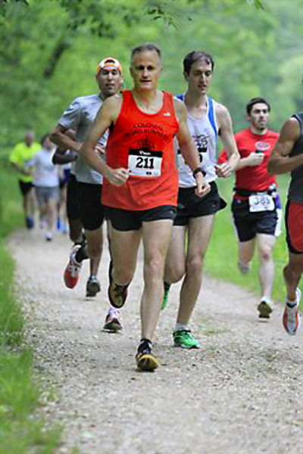
461 6 Stephen Roberts M 45 Fort Meade MD 1:55:39 Half 7:30
355 7 Katherine Lindbom F 23 Stafford VA 1:58:05 Half 7:30
358 8 Donald P. Loren  M 60 Alexandria VA 2:00:18 Half 7:30
354 9 Young Been Lim M 55 Gaithersburg MD 2:05:38 Half 7:30
557 10 Liat Weintraub F 37 Potomac MD 2:07:18 Half 7:30
125 11 Ashley Jean Barenz F 29 Brooklyn NY 2:12:51 Half 7:30
587 12 James Scarborough M 53 McLean VA 2:14:19 Half 7:30
530 13 Katherine Frances Thompson F 23 Alexandria VA 2:19:00 Half 7:30
375 14 Karolina Mazur F 25 Alexandria VA 2:20:44 Half 7:30
418 15 Adwoa S. Opoku-Boateng F 33 New Orleans LA 2:25:01 Half 7:30
402 16 Ronald Morrison M 61 Annandale VA 2:27:16 Half 7:30
534 17 Paige Noelle Topper F 19 Middletown MD 2:28:10 Half 7:30
476 18 Debra Saltz F 44 Ellicott City MD 2:29:52 Half 7:30
270 19 Laura Grzybowski F 28 Silver Spring MD 2:30:17 Half 7:30
210 20 Casey Dawson F 20 Bethesda MD 2:33:52 Half 7:30
685 21 Kathy Cordelli F 57 Ijamsville MD 2:46:16 Half 7:30
672 22 Radhika Chigurupati F 45 Baltimore MD 2:49:57 Half 7:30
236 23 Vivian English F 51 Fort Washington MD 2:57:22 Half 7:30 Greg Dawson
227 24 Gilian Dudley F 33 Riverside CA 3:08:07 Half 7:30

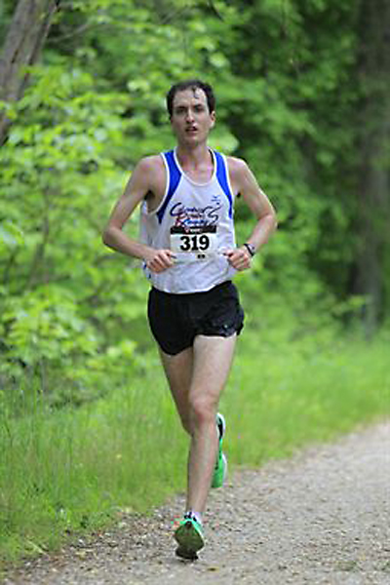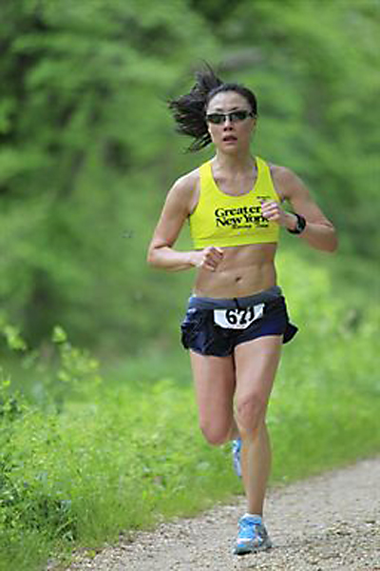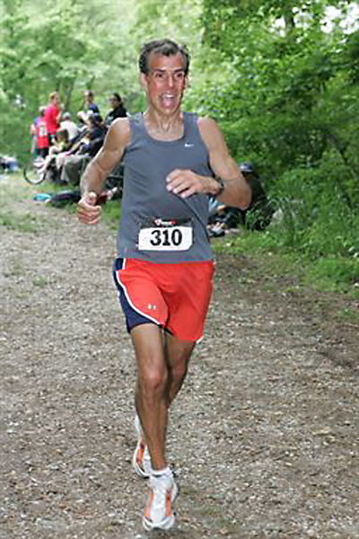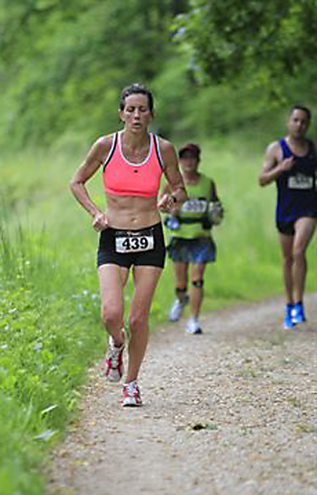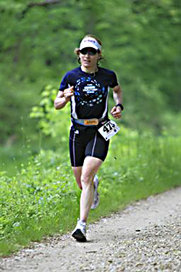
Kaleb Keyserling Judy Chen Thomas Patrick Jensen Jennifer Quarles Kim Ruple

