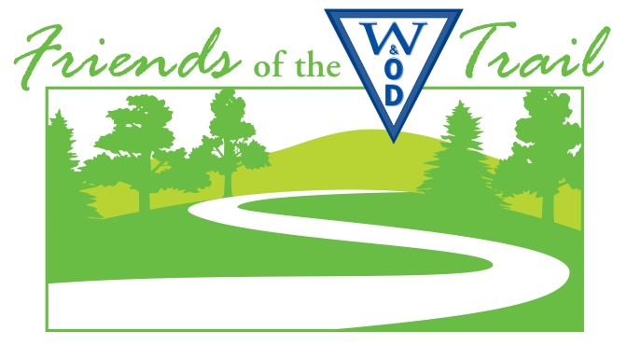



W&OD 10K
Saturday, August 4, 2018 – 6:00 PM
www.safetyandhealthfoundation.org/friends
www.wodfriends.org
www.safetyandhealthfoundation.org

ACE Physical Therapy & Sports Medicine Institute, Safety And Health Foundation, and Friends of the W&OD Trail welcome you to the 12th annual W&OD 10K, the DC area’s only 100% GREEN race.
As stewards of our environment on the longest park in Northern Virginia, we recycle, reduce, and re-use everything we can. All our printing is two-sided on recycled paper; we host a College of the Environment before and after the race; our t-shirts are printed using a non-polluting fusion process rather than traditional screen printing; and we recycle all our race-day wastes.
We hope today’s College of the Environment inspires you. If you visit ALL of our exhibitors, you win a special prize!
Please return this sheet to the registration desk for your prize at the awards presentation.

I visited these exhibitors: Bib # __ __ __ Name ____ ____ ____ ____ ____ ____ ____ ____ ____ ____ ____ ____ ____
Exhibitor Initials:
[___] Barbara Hildreth (“Mother of the W&OD Trail”) telling “The W&OD Trail: How it came to be” at 5:00 PM on race day

[___] ACE Physical Therapy & Sports Medicine Institute
[___] Altis Endurance Sports
[___] Freeman Store and Museum of Historic Vienna
[___] Lifetime Fitness
[___] Meadowlark Botanical Gardens
[___] Northern Virginia Regional Park Authority
[___] Rails-to-Trail Conservancy
[___] Velofix Northern Virginia
[___] The Women's Center (of Vienna)

COURSE MAP
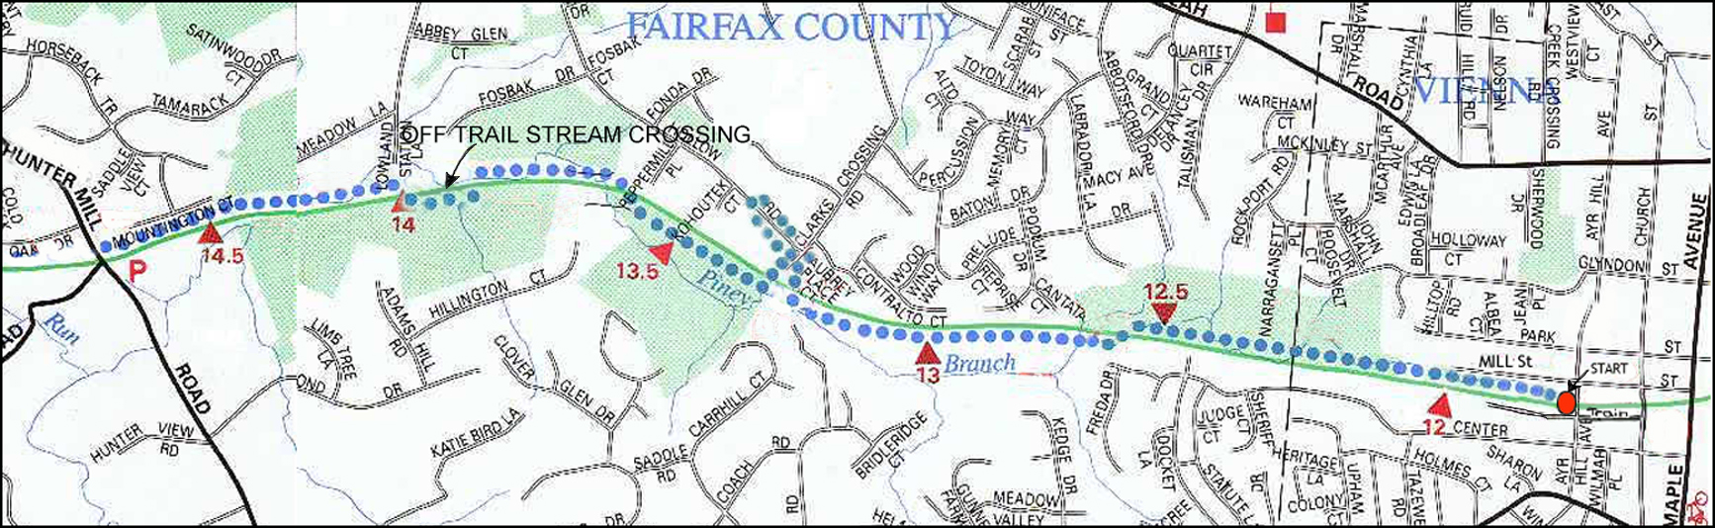

- At 5:00 PM, we invite you to meet Barbara Hildreth, chair of W&OD Task Force and the visionary behind the creation of W&OD Trail more than 50 years ago
- Her community organizing work began 10 years before the first mile of W&OD Trail got paved in Falls Church
- Listen to her presentation "The W&OD Trail: How It Came To Be" and be prepared with questions
- We thank ACE Physical Therapy for staffing registration and DC Capital Striders for running our aid stations
- The race starts and finishes on W&OD Trail at the third stripe 30 meters west of Ayr Hill Road
- On W&OD Trail, please stay on the right side so bicyclists and other users can enjoy the trail during the race
- On the way out, at 1.5 miles, turn right at aid station at Clarks Crossing, run through the small parking lot,
turn left onto Batten Hollow but stay right, turn around left at the fireplug near Kohoutek Court and stay right
- When you return to Clarks Crossing, turn right and stay right, then turn right back onto W&OD Trail
- At the aid station at Hunter Mill Road (3.3 miles), bear right onto the unpaved gravel path, then
turn left around the cones and run straight back on the paved W&OD Trail,
with no turn at the aid station at Clarks Crossing (4.5 miles)
Sincerely,
Jay Jacob Wind
Jay Jacob Wind
Secretary, Friends of the W&OD Trail
Director, Safety And Health Foundation
- PRE-RACE: Your services are urgently requested. Please join us to help us at packet assembly and packet pick-up
- Friday, August 3, 3:00 PM to 4:00 PM – Goodie Bag assembly
4:00 PM to 6:00 PM – Packet pick-up at ACE Physical Therapy and Sports Medicine Institute,
2841 Hartland Road #401B, Falls Church VA 22043 (703-205-1233)
one block east of Gallows Road, one block north of Lee Highway
ON RACE-DAY, PLEASE DO NOT PARK AT VIENNA ASSEMBLY OF GOD CHURCH PARKING LOT
- On race day, Saturday, August 4, College of the Environment exhibitors arrive about 4:00 PM
Come early if you want to help an exhibitor to set up
- On-site packet pick-up and race-day registration are open 4:15 PM to 5:45 PM in front of old red caboose next to W&OD trail
at Centennial Park, 131 Church Street NE, Vienna VA, across Church Street from Historic Vienna Inc. at Freeman House
- Our 12th annual College of the Environment with exhibitors in Centennial Park between Church Street and Ayr Hill Road,
plus Freeman House across Church Street, are open 4:15 PM to 8:00 PM. Come meet our exhibitors and sponsors
- We present a special award to everyone who visits all our exhibitors and gets each exhibitor's initials on your form.
Please return your form to the awards table by 7:15 PM
- At packet pick-up, get your t-shirt, goodie bag, and bib number.
In the spirit of reduce, recycle, re-use, W&OD 10K is the first race in the DC area to use BOLT electronic timing system using RFID, which makes collecting name-tags from the bottom of your bib number unnecessary.
Instead, each bib number has a waterproof, friction-proof transparent plastic envelope stapled to the back. Inside the envelope is a BOLT electronic timing chip, plus a mailing label. BOLT electronic timing chips are not cheap, and we intend to re-use them over and over in various future races, so we request your cooperation:
PLEASE DON'T REMOVE THE ENVELOPE, and please don't run a safety pin thru it, except if it comes loose, and if that happens, be sure to pin it only on thru the top, above the Ziploc.
Please wear your bib number clearly visible on the front of your shirt or shorts so that we can easily see it when you finish. The staple will keep the plastic envelope secure on the top of the back of your bib number. After you finish, please remove the envelope -- it comes right off when you tug on the staple -- and please deposit it in the box provided after the finish line, close to Ayr Hill Road.
At Ayr Hill Road, ACE Physical Therapy hosts a medical tent and provides a calligrapher to inscribe a finisher certificate with your name and finish time. Please turn in your envelope with the BOLT electronic timing chip before you go for your certificate.
If you pick up your number at packet pick-up, but you don't run the race, please give your plastic envelope and bib number back to the registrar or drop it into the box at Ayr Hill Road.
If you happen to go home and discover the BOLT electronic timing chip is still attached to your bib number or somewhere else near you, please remove the staple and mail the plastic envelope back to me, using the mailing label inside the envelope if you wish.
- At 5:30 PM, Ace Physical Therapy presents a pre-race warm-up in front of the old Vienna train station. Come join us!
- At 5:45 PM, we move to the start line across Ayr Hill to introduce our dignitaries including Virginia State Senator Chap Petersen, who has run our race every year, all Adopt-A-Trail members on hand, and our official starter, Dr. Mike Ercole of ACE-PT
- At 5:55 PM, we play the National Anthem. At 5:59 PM, we start baby-strollers. At 6:00 PM, we start runners
- After you finish, enjoy post-race refreshments
from Bare Snacks, Mario’s Pizza House, Great Harvest Bakery, and Whole Foods Market of Vienna
- At 7:15 PM, we present awards, including $250, $150, and $100 checks for 1st, 2nd, and 3rd male/female overall, and gifts
from Caboose Brewery, Falls Road Running Store, Northern Virginia Regional Park Authority, and other sponsors
for top 3 finishers M/F in 10-year age-groups
- Post-race, we recycle everything and make the campground cleaner than we found it. Please recycle everything in our bins
- Repurpose your used (but not abused) athletic shoes. Bring them to our collection point at College of the Environment
for More Foundation Group’s recycling (www.morefoundationgroup.org) (formerly Perpetual Prosperity Pumps Foundation)
- Portable toilets are west of Old Vienna Station at Ayr Hill Road and at Hunter Mill Road
We thank our volunteers: ACE Physical Therapy, DC Capital Striders, and W&OD Trail Patrol; College of the Environment leader Liza Recto; Friends of the W&OD president Pat Turner and other FoWOD directors, Trail Patrol members; David Garcia, Andy Kaganowich, Karl Mohle, Doranne Pittz, and others from Northern Virginia Regional Park Authority, and our sponsors:
- ACE Physical Therapy & Sports Medicine Institute, leading warm-up and pre-race / post-race musculo-skeletal evaluations

- Bare Snacks
- Caboose Brewing Company (visit 520 Mill Street NE after the race!)
- FastSigns of Fairfax
- Falls Road Running Store
- Great Harvest Bakery
- Mario’s Pizza House
- Rails-to-Trail Conservancy
- Sport Science > ®
- Velofix Northern Virginia
- Whole Foods Market of Vienna

- Post-race, we welcome comments and photos
on our Facebook page www.facebook.com/groups/FriendsOfTheWOD10K or e-mail to racedirector@att.net
- We publish full results at www.safetyandhealthfoundation.org/20180804.html
- Have fun, enjoy, be safe, and thank you for joining us!
Sincerely,
Jay Jacob Wind
Jay Jacob Wind, Secretary, Friends of the W&OD Trail; Director, Safety And Health Foundation

